**IBM ASSIGNMENT 3 – IOT DOMAIN**

1. **Link:**

<https://wokwi.com/projects/364540012436747265>

1. **Code:**

#include <WiFi.h>//library for wifi

#include <PubSubClient.h>//library for MQtt

const int trigPin = 12;  // trig pin of the ultrasonic sensor

const int echoPin = 13; // echo pin of the ultrasonic sensor

void callback(char* subscribetopic, byte* payload, unsigned int payloadLength);

//-------credentials of IBM Accounts------

#define ORG "okjiu4"//IBM ORGANITION ID

#define DEVICE_TYPE "abcd"//Device type mentioned in ibm watson IOT Platform

#define DEVICE_ID "12345"//Device ID mentioned in ibm watson IOT Platform

#define TOKEN "87654321"     //Token

String data3;

long duration, distance_cm;

//-------- Customise the above values --------

char server[] = ORG ".messaging.internetofthings.ibmcloud.com";// Server Name

char publishTopic[] = "iot-2/evt/Data/fmt/json";// topic name and type of event perform and format in which data to be send

char subscribetopic[] = "iot-2/cmd/command/fmt/String";// cmd  REPRESENT command type AND COMMAND IS TEST OF FORMAT STRING

char authMethod[] = "use-token-auth";// authentication method

char token[] = TOKEN;

char clientId[] = "d:" ORG ":" DEVICE_TYPE ":" DEVICE_ID;//client id

//-----------------------------------------

WiFiClient wifiClient; // creating the instance for wificlient

PubSubClient client(server, 1883, callback ,wifiClient);

void setup() {

**Serial**.begin(9600);  // initialize serial communication

  pinMode(trigPin, OUTPUT); // set trig pin as output

  pinMode(echoPin, INPUT);  // set echo pin as input

  wificonnect();

  mqttconnect();

}

void loop() {

  digitalWrite(trigPin, LOW);  // send a low pulse to trig pin

  delayMicroseconds(2);

  digitalWrite(trigPin, HIGH); // send a high pulse to trig pin for 10 microseconds

  delayMicroseconds(10);

  digitalWrite(trigPin, LOW);

  duration = pulseIn(echoPin, HIGH);  // read the duration of the pulse from echo pin

  distance_cm = duration / 1000;  // calculate distance in cm

  if(distance_cm <=100){

**Serial**.print("Distance: ");

**Serial**.print(distance_cm);

**Serial**.println(" cm");

    PublishData(distance_cm);

    delay(1000);

    if (!client.loop()) {

      mqttconnect();

  }

  }

  else{

**Serial**.println("Distance is greater than 100 ,we cannot print and sent to cloud");

  }

  delay(1000);  // wait for 1 second before taking the next measurement

}

void PublishData(int distance) {

  mqttconnect();//function call for connecting to ibm

  /*

     creating the String in in form JSon to update the data to ibm cloud

  */

  String payload = "{\"distance\":";

  payload += distance;

  payload += "}";

**Serial**.print("Sending payload: ");

**Serial**.println(payload);

  if (client.publish(publishTopic, (char*) payload.c_str())) {

**Serial**.println("Publish ok");// if it sucessfully upload data on the cloud then it will print publish ok in Serial monitor or else it will print publish failed

  } else {

**Serial**.println("Publish failed");

  }

}

void mqttconnect() {

  if (!client.connected()) {

**Serial**.print("Reconnecting client to ");

**Serial**.println(server);

    while (!!!client.connect(clientId, authMethod, token)) {

**Serial**.print(".");

      delay(500);

    }

     initManagedDevice();

**Serial**.println();

  }

}

void wificonnect() //function defination for wificonnect

{

**Serial**.println();

**Serial**.print("Connecting to ");

  WiFi.begin("Wokwi-GUEST", "", 6);//passing the wifi credentials to establish the connection

  while (WiFi.status() != WL_CONNECTED) {

    delay(500);

**Serial**.print(".");

  }

**Serial**.println("");

**Serial**.println("WiFi connected");

**Serial**.println("IP address: ");

**Serial**.println(WiFi.localIP());

}

void initManagedDevice() {

  if (client.subscribe(subscribetopic)) {

**Serial**.println((subscribetopic));

**Serial**.println("subscribe to cmd OK");

  } else {

**Serial**.println("subscribe to cmd FAILED");

  }

}

void callback(char* subscribetopic, byte* payload, unsigned int payloadLength)

{

**Serial**.print("callback invoked for topic: ");

**Serial**.println(subscribetopic);

  for (int i = 0; i < payloadLength; i++) {

    //Serial.print((char)payload[i]);

    data3 += (char)payload[i];

  }

**Serial**.println("data: "+ data3);

}

1. **Connections Screenshot:**

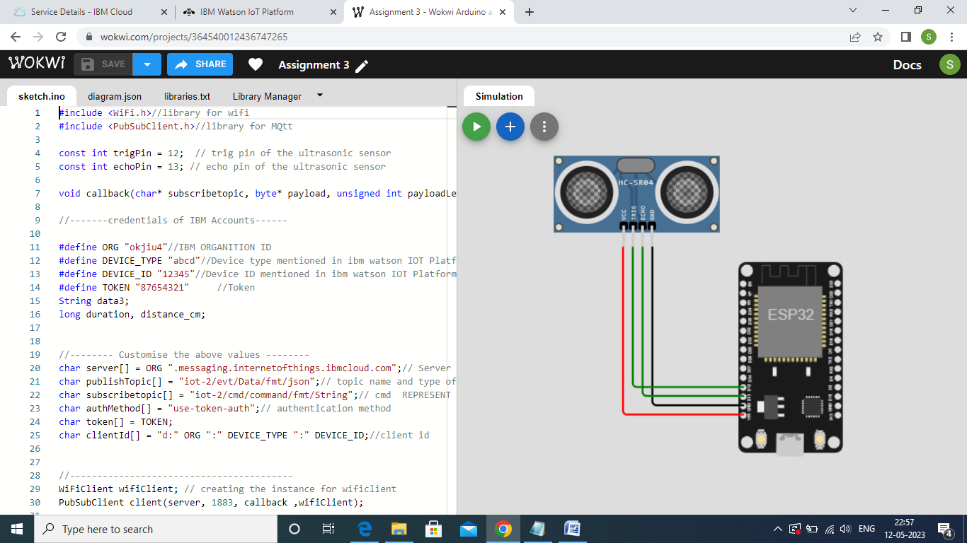

1. **IBM Cloud Recent Events Screenshot:**

